**CHAPTER 1**

**INTRODUCTION**

In the era of digital commerce, online product reviews have become an essential factor influencing consumer purchasing decisions. Customers share their experiences and opinions about products, providing valuable feedback that businesses can leverage to enhance their services and product quality. However, the vast volume of customer reviews generated daily makes it impractical to manually analyse and interpret sentiments accurately. This challenge has led to the rise of Sentiment Analysis, a subfield of Natural Language Processing (NLP) that involves using computational techniques to automatically determine the sentiment expressed in textual data.

Sentiment Analysis is widely applied in various industries, including e-commerce, social media monitoring, brand reputation management, and customer feedback analysis. By classifying reviews into categories such as positive, negative, or neutral, businesses can gain insights into customer satisfaction levels, identify product strengths and weaknesses, and make data-driven improvements.

This project focuses on developing a Sentiment Analysis model for product reviews using Machine Learning techniques. The objective of this study is to develop an efficient Sentiment Analysis model that can accurately classify customer reviews based on sentiment polarity. By evaluating and comparing different feature extraction methods, we aim to determine the most effective approach for sentiment prediction. The insights from this research can be valuable for businesses seeking to automate review analysis and enhance customer experience through data-driven strategies

* 1. **NATURAL LANGUAGE PROCESSING (NLP)**

Natural Language Processing (NLP) is a subfield of artificial intelligence (AI) that enables machines to understand, interpret, and generate human language. NLP bridges the gap between human communication and machine comprehension by using computational techniques to process textual data. According to Vajjala et al. (2020), NLP systems aim to "extract meaning from text and use it for a specific task, such as classification, translation, or summarization" *(Chapter 1, Introduction to NLP)(1)*.

Over the years, NLP has evolved significantly, incorporating machine learning (ML) and deep learning (DL) techniques to improve the accuracy and efficiency of language-based models. These advancements have led to widespread applications in chatbots, sentiment analysis, recommendation systems, and automated content moderation *(Vajjala et al., 2020, Chapter 2, The NLP Pipeline)(1)*.

In this project, we apply NLP techniques to analyse product reviews and classify them based on sentiment (positive, negative, or neutral). Manually analysing thousands of reviews is impractical, and NLP enables us to automate this process efficiently.

Feature Extraction for Sentiment Analysis

To convert text into a numerical format that machine learning models can understand, we use various feature extraction techniques, including:

* TF-IDF (Term Frequency-Inverse Document Frequency): Identifies important words in a document relative to a collection of documents.
* CountVectorizer: Converts text into a matrix of token counts, representing word frequency.
* Word Embeddings (e.g., Word2Vec, GloVe): Captures semantic relationships between words.

Vajjala et al. (2020) emphasize that choosing the right feature representation is critical to NLP model performance *(Chapter 4, Feature Engineering for NLP)(1)*.

Sentiment Classification Using Machine Learning

We use Random Forest, a popular ensemble learning method, for sentiment classification. NLP helps improve the model’s performance by providing structured text features through preprocessing and feature extraction.

According to Vajjala et al. (2020), "Supervised learning models, such as Random Forest, can achieve high accuracy when trained on well-pre-processed NLP data" *(Chapter 5, Machine Learning for NLP)(1)*.

**1.2 MACHINE LEARNING TECHNIQUES**

Machine Learning (ML) is a subset of artificial intelligence that enables computers to learn from data and make predictions without being explicitly programmed. It is widely used in various applications, such as image recognition, recommendation systems, fraud detection, and natural language processing (NLP).

According to Oliver Theobald (2017), *"Machine learning allows systems to identify patterns in data and make decisions with minimal human intervention."* *(Chapter 1, Introduction to Machine Learning)(2)*. This ability to learn and improve from experience makes ML an ideal approach for analyzing large volumes of unstructured text data, such as product reviews.

In our project, we use Machine Learning to perform Sentiment Analysis on product reviews. Instead of manually categorizing thousands of customer reviews as positive, negative, or neutral, we train an ML model to classify the sentiment automatically and accurately

Traditionally, sentiment analysis was performed through manual review or rule-based methods. However, these approaches are time-consuming and inefficient for large datasets, Struggle with complex language variations, sarcasm, and context.

Machine Learning overcomes these challenges by learning patterns from labelled data and generalizing them to new, unseen reviews. As explained by Aurélien Géron (2019), *"Supervised learning techniques, such as Random Forest and Neural Networks, enable models to classify text efficiently based on prior training data."* *(Chapter 2, End-to-End Machine Learning Project)(3)*.

In our project, we implement a Random Forest classifier, a powerful ML algorithm that improves classification accuracy by aggregating multiple decision trees.

One of the key benefits of ML in our project is its ability to generalize well to new data. The Random Forest classifier, which we use for sentiment classification, has several advantages, handles high-dimensional data effectively, reduces overfitting by combining multiple decision trees, provides robust performance across different datasets.

As Theobald (2017) states, *"Ensemble methods such as Random Forest improve classification accuracy by aggregating the outputs of multiple models."* *(Chapter 5, Classification Algorithms)(2)*.

By leveraging ML, our model can classify new, unseen reviews with high accuracy, making it a scalable solution for real-world sentiment analysis.

* 1. **PANDAS**

In our Sentiment Analysis of Product Reviews project, we use Pandas for efficient data handling, preprocessing, and transformation, as emphasized in *Python for Data Analysis* by Wes McKinney (2017) (4). Since our dataset consists of large volumes of textual reviews, Pandas helps in loading, cleaning, and structuring the data into DataFrames, making it easier to manipulate (4). The book highlights how handling missing values, filtering data, and merging datasets are crucial steps in real-world data analysis, which directly apply to our text preprocessing workflow. Additionally, Pandas’ integration with NumPy allows for optimized numerical operations, improving the performance of feature extraction techniques like TF-IDF and CountVectorizer. As McKinney (2017) explains, efficient grouping, aggregation, and visualization capabilities in Pandas enable us to explore sentiment trends, ensuring high-quality data for training our machine learning model (4).

In our Sentiment Analysis of Product Reviews project, we use Streamlit to build an interactive and user-friendly web application for visualizing sentiment predictions. As highlighted in *Python for Data Analysis* by Wes McKinney (2017), effective data presentation is crucial for making insights accessible, and Streamlit enables us to achieve this by displaying sentiment results, visualizing data trends, and allowing users to input their own text for analysis in real-time. With its simplicity and Python-based framework, Streamlit eliminates the need for complex front-end development, allowing us to focus on integrating Pandas for data handling and matplotlib/seaborn for sentiment visualizations. By leveraging Streamlit’s interactive UI components, we enhance the usability of our project, making it an effective tool for businesses and researchers to analyze customer sentiment.

**CHAPTER 2**

**LITERATURE REVIEW**

**2.1 Practical Natural Language Processing: A Comprehensive Guide to Building Real-World NLP Systems (1)**

"Practical Natural Language Processing: A Comprehensive Guide to Building Real-World NLP Systems" by Vajjala, Majumder, Gupta, and Surana is a seminal work that provides a deep dive into the multifaceted world of NLP, bridging theoretical foundations with practical applications in a manner that is both accessible and technically rigorous. The book lays out a clear roadmap for constructing NLP systems, beginning with the core principles of text processing such as tokenization, stemming, and lemmatization, which are essential for transforming raw, unstructured text into data that machines can analyze. Throughout its extensive treatment, the text emphasizes that the journey from raw data to actionable insights involves a series of interdependent steps, each critical to the overall performance of any NLP system. One of the book’s notable contributions is its detailed exploration of feature extraction techniques. The authors describe traditional methods such as TF-IDF and CountVectorizer, which serve as the starting point for representing text numerically, and then progress to more advanced techniques like word embeddings, including Word2Vec, GloVe, and FastText, which have revolutionized the way contextual and semantic relationships are captured in text. This evolution in methodology is discussed not just as a historical progression but as a practical guide for selecting the appropriate technique based on the specific demands of the application at hand, such as sentiment analysis of product reviews. Moreover, the book delves into the application of various machine learning algorithms to NLP tasks, discussing models ranging from classical approaches like Naïve Bayes and Support Vector Machines to ensemble methods like Random Forests, which are highlighted for their robustness in handling high-dimensional data and mitigating overfitting. The discussion is enriched by real-world examples and case studies that illustrate how these models are deployed in industry settings, thus underscoring the practical challenges and considerations involved in transitioning from a prototype to a production-ready system. The authors also provide critical insights into the challenges of model interpretability, bias, and fairness—issues that are increasingly significant in today’s AI-driven world—thereby encouraging practitioners to consider the ethical dimensions of deploying NLP technologies. An emphasis is placed on the iterative nature of developing NLP systems, where continuous refinement through feedback loops is essential to achieving high performance and reliability. Additionally, the book covers the integration of NLP models with modern software architectures, discussing topics such as scalability, real-time processing, and the use of cloud-based platforms to manage large volumes of data, which are particularly pertinent to projects dealing with dynamic data sources like online product reviews. The comprehensive treatment of error analysis and performance tuning is another strength of the work, offering readers practical strategies for diagnosing issues in their models and systematically improving accuracy and robustness. By drawing on a wide range of examples—from simple text classification tasks to complex sentiment analysis and language generation—the book serves as both a reference manual and a tutorial, guiding readers through the nuances of model training, validation, and deployment. In doing so, it reinforces the idea that the success of an NLP project depends not only on selecting the right algorithms but also on a thoughtful integration of data preprocessing, feature engineering, and ethical considerations. Overall, "Practical Natural Language Processing" stands out for its balanced approach that combines deep technical insights with pragmatic advice, making it an indispensable resource for both researchers and practitioners. It provides a clear, methodical framework for approaching the many challenges inherent in natural language data, thereby empowering developers to build more effective, reliable, and ethically sound NLP systems. This comprehensive guide not only demystifies the complexities of NLP but also inspires confidence in the practical application of these techniques, making it an essential text for anyone looking to navigate the rapidly evolving landscape of language technologies.

2.2 **Hands-On Machine Learning with Scikit-Learn, Keras, and TensorFlow by Aurélien Géron. (3)**

Machine Learning (ML) has become an integral part of modern artificial intelligence, powering various applications ranging from recommendation systems to natural language processing (NLP) and predictive analytics. "Hands-On Machine Learning with Scikit-Learn, Keras, and TensorFlow" by Aurélien Géron is one of the most widely regarded books for practitioners and researchers looking to understand and implement machine learning models effectively. The book provides a comprehensive yet practical approach to ML, focusing on real-world applications rather than just theoretical concepts. Géron structures the book in a way that makes it accessible to both beginners and experienced practitioners by combining intuitive explanations, hands-on coding exercises, and in-depth discussions on modern ML techniques.

One of the book’s strongest features is its focus on using Scikit-Learn, Keras, and TensorFlow, three of the most widely used libraries in ML. Géron begins with fundamental machine learning concepts such as supervised and unsupervised learning, model evaluation, and performance metrics, laying the foundation for deeper exploration into complex algorithms. The book introduces linear regression, decision trees, support vector machines (SVMs), and ensemble methods such as random forests and gradient boosting, providing hands-on implementation details that help readers understand the behavior of these models. This discussion is particularly relevant to our Sentiment Analysis of Product Reviews project, where Random Forest Classifiers are used to classify sentiments, demonstrating the practical applicability of the techniques covered in the book. The author provides a detailed walkthrough of feature selection, data preprocessing, and dimensionality reduction techniques such as Principal Component Analysis (PCA) and t-SNE, which are crucial for optimizing machine learning models by reducing noise and improving computational efficiency.

A significant portion of the book is dedicated to deep learning, where Géron introduces artificial neural networks (ANNs), convolutional neural networks (CNNs), and recurrent neural networks (RNNs), including LSTMs and GRUs, which are particularly effective for sequential data like text. The discussion on deep learning aligns with our project’s exploration of word embeddings and feature engineering, as techniques like Word2Vec, GloVe, and FastText are frequently used in NLP applications. Géron explains how TensorFlow and Keras can be used to build and train deep learning models, making the book a valuable resource for projects that may require scalability beyond traditional ML approaches. The book also covers transfer learning and reinforcement learning, providing insights into advanced ML techniques that are increasingly being applied in various domains, including NLP and sentiment analysis.

Another critical aspect of the book is its emphasis on model evaluation, hyperparameter tuning, and optimization techniques. Géron demonstrates how to use GridSearchCV, RandomizedSearchCV, and Bayesian optimization to fine-tune machine learning models, ensuring they achieve higher accuracy and generalization. This aligns with our sentiment analysis project, where hyperparameter tuning plays a crucial role in improving the performance of the Random Forest classifier. Furthermore, the book discusses the importance of cross-validation, bias-variance tradeoff, and regularization techniques, which are essential for developing robust ML models.

Beyond model training, Géron places a strong emphasis on the deployment and scaling of ML models in real-world applications. He discusses topics such as saving and loading models, serving ML models using TensorFlow Serving, and deploying models in cloud environments, making the book a practical guide for production-level implementation. This is particularly useful for applications where real-time or large-scale sentiment analysis is required, ensuring that the models built are efficient, scalable, and suitable for dynamic data streams. Additionally, the book addresses ethical considerations in ML, including bias in models, interpretability, and fairness, which are important in sentiment analysis to ensure that customer opinions are analyzed in an unbiased and transparent manner.

In the later chapters, Géron explores the latest advancements in ML and AI, such as generative adversarial networks (GANs), reinforcement learning, and transformers, making the book a continually relevant resource even as ML techniques evolve. The structured approach taken by the book—starting from fundamental ML principles and progressively moving towards deep learning and advanced AI topics—makes it an invaluable guide for understanding both classical and modern ML techniques.

Overall, "Hands-On Machine Learning with Scikit-Learn, Keras, and TensorFlow" stands out as an excellent resource for both beginners and professionals aiming to build efficient, scalable, and high-performing ML models. The book’s hands-on approach, practical coding exercises, and industry-relevant examples make it particularly beneficial for our Sentiment Analysis of Product Reviews project, where ML techniques are applied to extract meaningful insights from customer feedback. Géron’s emphasis on model selection, tuning, deployment, and ethical considerations ensures that ML practitioners are not only able to build effective models but also deploy them responsibly in real-world scenarios. By covering the entire lifecycle of ML development—from data preprocessing and feature engineering to deep learning and deployment—the book serves as a comprehensive guide for understanding and implementing machine learning in practice.

**2.3 Machine Learning for Absolute Beginners by Oliver Theobald (2).**

Machine learning (ML) has become a fundamental technology across various industries, enabling computers to make intelligent decisions based on data. "Machine Learning for Absolute Beginners" by Oliver Theobald serves as an introductory guide for those new to the field, providing a simplified yet comprehensive overview of core machine learning concepts. Unlike more technical books, this book is written in an accessible, jargon-free manner, making it particularly useful for beginners who may not have a background in mathematics or programming. Theobald systematically introduces essential ML principles, offering clear explanations and practical examples that help readers understand how machine learning models are designed, trained, and evaluated.

The book begins by defining machine learning as a subset of artificial intelligence (AI), where algorithms learn from data without being explicitly programmed. Theobald emphasizes that ML is about identifying patterns in data and making predictions based on those patterns, a concept that directly aligns with our Sentiment Analysis of Product Reviews project, where patterns in customer feedback are analyzed to determine sentiment. He provides an introduction to supervised and unsupervised learning, explaining their differences and applications. Supervised learning, which involves training models on labeled data, is particularly relevant to our project since sentiment classification requires labeled datasets where each review is marked as positive, negative, or neutral.

One of the strengths of the book is its discussion on data preprocessing and feature engineering, which are crucial steps in building effective ML models. Theobald explains the importance of cleaning data, handling missing values, and converting categorical data into numerical form—all of which are necessary steps in preparing text data for sentiment analysis. He also introduces basic feature extraction techniques such as TF-IDF and one-hot encoding, which are essential for transforming textual data into a machine-readable format. This aligns with our use of TF-IDF and CountVectorizer for extracting relevant features from product reviews before training our Random Forest classifier.

The book also covers fundamental machine learning algorithms, including linear regression, decision trees, k-nearest neighbors (KNN), Naïve Bayes, and support vector machines (SVMs). While these models are introduced at a high level, Theobald provides practical examples that help beginners grasp their applications. The discussion on decision trees and ensemble methods like Random Forests is particularly relevant to our project, as Random Forest is the primary classification algorithm used in our sentiment analysis model. The book explains how Random Forest combines multiple decision trees to improve accuracy and reduce overfitting, making it a powerful choice for text classification tasks.

A key aspect of machine learning that Theobald highlights is model evaluation and performance metrics. He explains how metrics like accuracy, precision, recall, and F1-score are used to measure the effectiveness of a model. These metrics are crucial in our sentiment analysis project, where evaluating the classifier’s performance ensures that the sentiment predictions are reliable. The book provides simple yet effective explanations of concepts like confusion matrices and cross-validation, which help readers understand how to test and refine ML models.

Although the book primarily focuses on classical ML techniques, Theobald also introduces deep learning as an extension of machine learning. He briefly discusses neural networks, backpropagation, and the role of activation functions, providing a foundational understanding of deep learning concepts. While deep learning is not the primary focus of our project, these insights could be useful for future improvements, such as experimenting with recurrent neural networks (RNNs) or transformer models like BERT for sentiment analysis.

Another significant aspect of the book is its discussion on bias, ethics, and challenges in machine learning. Theobald emphasizes that machine learning models can inherit biases from training data, which is particularly important in sentiment analysis, where biased datasets can lead to skewed predictions. This ties into our project’s objective of ensuring fairness and reducing bias in sentiment classification, reinforcing the need for careful dataset selection and evaluation.

Overall, "Machine Learning for Absolute Beginners" provides an excellent foundation for those new to ML, offering clear explanations and practical insights without overwhelming readers with complex mathematics or code-heavy examples. While it does not go as deep as more advanced books like "Hands-On Machine Learning with Scikit-Learn, Keras, and TensorFlow", it serves as a stepping stone for understanding key ML concepts. The book’s focus on supervised learning, feature extraction, model evaluation, and bias mitigation makes it a relevant resource for our Sentiment Analysis of Product Reviews project, reinforcing fundamental principles that guide the development of reliable ML models. The simplicity and clarity of Theobald’s explanations make this book a great reference for beginners looking to build practical ML applications while gaining a conceptual understanding of how machine learning contributes to real-world problem-solving.

**2.4 Python for Data Analysis: Data Wrangling with Pandas, NumPy, and Jupyter by Wes McKinney. (4)**

Data analysis is a fundamental step in any machine learning or natural language processing (NLP) project, as it involves cleaning, transforming, and organizing raw data to extract meaningful insights. "Python for Data Analysis: Data Wrangling with Pandas, NumPy, and Jupyter" by Wes McKinney is one of the most comprehensive resources for mastering data manipulation using Pandas, NumPy, and Jupyter Notebooks. Written by the creator of Pandas, this book provides an in-depth look at efficient data handling techniques, making it an essential guide for data scientists, analysts, and machine learning practitioners.

The book begins with an introduction to Python and its ecosystem for data analysis, emphasizing why Python has become the leading language for working with structured and unstructured data. McKinney highlights the importance of efficient data structures and demonstrates how libraries like NumPy and Pandas help in handling large datasets with ease. Given that our Sentiment Analysis of Product Reviews project deals with text data, understanding data structures, indexing, and efficient memory management is crucial for ensuring smooth preprocessing and feature extraction.

One of the book’s key contributions is its detailed explanation of Pandas, a library designed for handling tabular and structured data. McKinney covers the core Pandas data structures, such as Series and DataFrames, explaining how they enable efficient data manipulation. He provides step-by-step guidance on loading, cleaning, and transforming data, which is particularly useful in our sentiment analysis project, where we must preprocess large volumes of product reviews before feeding them into a machine learning model. The book also covers handling missing values, filtering data, and performing group operations, all of which are essential in real-world ML workflows.

A major focus of the book is data wrangling, which involves transforming raw data into a structured format suitable for analysis. McKinney provides extensive discussions on merging, reshaping, and aggregating datasets, which are crucial techniques when working with multiple sources of information. These techniques directly apply to our project, as product review datasets often require merging different data sources, handling duplicates, and structuring text data for feature extraction. The book also introduces time series analysis, an important topic for analyzing trends in customer reviews over time, helping businesses track sentiment shifts.

McKinney also covers NumPy, a foundational library for numerical computing, and explains how its efficient array operations complement Pandas when working with large datasets. Vectorized operations in NumPy help speed up calculations, making data transformations significantly faster than traditional loops. This is particularly useful in feature engineering for TF-IDF, CountVectorizer, and word embeddings, where large text datasets require optimized numerical operations for better performance.

Another significant aspect of the book is its focus on data visualization using libraries like Matplotlib and Seaborn. McKinney demonstrates how histograms, scatter plots, and box plots can be used to explore datasets before applying machine learning algorithms.

A standout feature of the book is its discussion on Jupyter Notebooks, a tool widely used for interactive coding, debugging, and documentation in data science. McKinney explains how Jupyter enhances the workflow of ML practitioners by allowing them to test and visualize data processing steps in real time, making it a valuable tool for our sentiment analysis project.

Moreover, McKinney emphasizes best practices for data analysis, including performance optimization, memory management, and debugging techniques. His discussion on vectorized operations, efficient indexing, and parallel processing is particularly useful when dealing with large-scale NLP tasks, where performance bottlenecks can impact model training and prediction times.

In the final chapters, the book covers real-world data analysis case studies, demonstrating how Pandas and NumPy are applied in business and research. These practical examples reinforce the importance of data preprocessing, cleaning, and feature engineering, all of which are critical components in our project. The book also touches on scalability challenges and working with big data, making it an excellent resource for preparing machine learning pipelines for production deployment.

Overall, "Python for Data Analysis" by Wes McKinney (4) is an essential resource for mastering data manipulation in machine learning workflows. The book’s detailed coverage of Pandas, NumPy, and Jupyter Notebooks makes it highly relevant to our Sentiment Analysis of Product Reviews project, as it provides the necessary tools for cleaning, structuring, and analyzing text data before applying machine learning models. McKinney’s emphasis on efficient data handling, performance optimization, and real-world applications ensures that readers not only understand the theoretical aspects of data analysis but also develop the practical skills needed to work with large datasets in machine learning environment

*Data wrangling and analysis are the foundation of modern data science, and Pandas provides the essential tools for efficiently manipulating, cleaning, and transforming data to extract meaningful insights."* *(McKinney, 2017)(4)*

This highlights how Pandas simplifies complex data operations, making it indispensable for data preprocessing in machine learning and NLP applications like your Sentiment Analysis of Product Reviews project

(4).

**CHAPTER 3**

**METHODOLOGY**

**3.1 EXISTING SYSTEM**

In the realm of sentiment analysis for product reviews, certain systems have demonstrated limitations that hinder their effectiveness. For instance, earlier approaches often relied on simple keyword-based methods, which lacked the sophistication to accurately interpret context, sarcasm, or nuanced expressions within reviews. These methods typically involved matching words from reviews to predefined sentiment lexicons, assigning positive or negative scores based on word presence. However, such systems struggled with polysemous words—terms that carry different meanings depending on context—and failed to account for negations or intensifiers, leading to misclassification of sentiments. Additionally, the absence of advanced preprocessing steps, such as handling misspellings, slang, or domain-specific jargon, further compromised the accuracy of these models. Consequently, these underperforming systems provided limited insights, often misguiding businesses in understanding customer sentiments and making data-driven decisions. ​

**3.2 PROPOSED SYSTEM**

Compared to traditional sentiment analysis systems, which relied on basic keyword matching and lexicon-based approaches, our system offers a more robust and accurate approach using machine learning techniques. Earlier systems struggled with context understanding, sarcasm, negations, and domain-specific language, often leading to incorrect sentiment classification. They lacked the ability to adapt to new data and were highly dependent on predefined word lists, making them rigid and ineffective in real-world applications.

In contrast, our Sentiment Analysis of Product Reviews system leverages a Random Forest Classifier (RFC), a powerful machine learning model that learns from data patterns rather than relying on predefined word lists. Instead of simple word matching, we use CountVectorizer to transform text into numerical representations, allowing the model to capture the frequency and importance of words within a review. Additionally, Label Encoding ensures that our sentiment labels are processed in a structured manner, further improving classification accuracy.

Unlike underperforming systems that lack proper preprocessing, our model ensures effective data cleaning by handling missing values and text transformation, significantly enhancing the quality of the training data. Moreover, by using ensemble learning (Random Forest), our model reduces overfitting and generalizes well to new, unseen reviews, unlike traditional models that fail when exposed to different writing styles or slang.

Furthermore, our system provides a user-friendly web interface using Streamlit, allowing users to input text and instantly receive sentiment predictions. Older systems often required manual input and complex workflows, making them inefficient for real-world use. Additionally, the loading spinner, video guide, and sidebar features enhance usability, ensuring a seamless and interactive experience.

In summary, our ML-based sentiment analysis system significantly outperforms traditional rule-based methods by incorporating advanced NLP techniques, automated learning, and an intuitive web-based deployment. By eliminating

rigid keyword dependency, improving context recognition, and enhancing user interaction, our system offers a more accurate, scalable, and efficient solution for sentiment classification.

**3.3 DATA COLLECTION AND PRE-PROCESSING**

Data collection involves gathering textual data from sources like product reviews, social media, and customer feedback, ensuring a diverse and representative dataset. Preprocessing is the crucial step of cleaning and transforming raw text into a structured format suitable for machine learning. This includes removing noise, handling missing values, tokenization, stopword removal, and feature extraction using methods like TF-IDF or CountVectorizer. These steps enhance data quality, model performance, and sentiment classification accuracy, making sentiment analysis more reliable and efficient

**3.3.1 DATA INGESTION**

In our Sentiment Analysis of Product Reviews project, data ingestion involves loading the dataset (Dataset-SA.csv) into a Pandas DataFrame for further processing. The dataset contains product reviews and their corresponding sentiment labels, which are read and structured using Pandas’ read_csv() function.

**3.3.2 DATA CLEANING**

In our **Sentiment Analysis of Product Reviews** project, data cleaning ensures that the dataset is free from inconsistencies, missing values, and unnecessary noise. After data ingestion, missing values in the **review summaries and sentiment labels** are handled by filling them with default values to avoid disruptions during training. The text data is standardized by **removing extra spaces, converting to lowercase, and handling null entries** to maintain uniformity. Additionally, non-relevant characters such as **punctuation, special symbols, and numbers** are removed to improve text quality.

**3.3.3 EXPLORATORY DATA ANALYSIS**

Visualization techniques such as bar charts, histograms, and word clouds can be used to explore frequent words and patterns in the reviews. Analyzing text length distributions helps identify anomalies like excessively short or long reviews that might impact model performance. Additionally, correlation analysis between word occurrences and sentiment labels provides insights into which words strongly contribute to each sentiment category.

Through EDA, we gain a deeper understanding of the dataset’s quality, allowing us to make informed preprocessing decisions that improve the performance of our Random Forest classifier.

**3.4 FEATURE EXTRACTION**

In our Sentiment Analysis of Product Reviews project, feature extraction is a crucial step that transforms raw text into a numerical format that the Random Forest Classifier can process. We use CountVectorizer, a Bag-of-Words (BoW) technique, to convert text data into a matrix of token counts, where each unique word in the dataset becomes a feature. This method helps the model understand the frequency of words in reviews.

**3.5 MODEL SELECTION**

In our Sentiment Analysis of Product Reviews project, we could use different machine learning algorithms, but we chose the Random Forest Classifier (RFC) over Logistic Regression due to its superior performance for text classification tasks. Here’s a comparison between the two

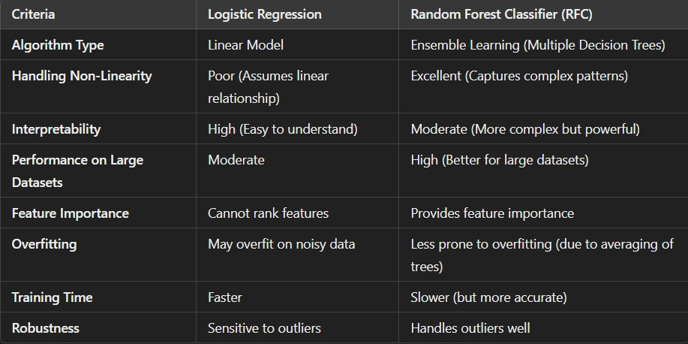

3.5.1 LOGISTIC REGRESSION VS RANDOM FOREST CLASSIFIER

**3.6 RANDOM FOREST CLASSIFIER**

The Random Forest Classifier (RFC) is the core machine learning model used in our Sentiment Analysis of Product Reviews project, enabling us to classify customer reviews as positive, negative, or neutral with high accuracy and robustness. As an ensemble learning algorithm, RFC builds multiple Decision Trees, each trained on a random subset of the dataset and a random selection of text features extracted using CountVectorizer. This method enhances the model’s ability to capture patterns in textual data while preventing overfitting, a common issue in single-tree classifiers. During prediction, RFC employs a majority voting mechanism, where each tree predicts a sentiment label, and the final classification is determined based on the most common outcome, ensuring reliable and consistent predictions.

In our project, feature extraction is performed using CountVectorizer, which transforms textual product reviews into numerical feature vectors representing word frequency. These vectors serve as inputs to the RFC model, allowing it to learn meaningful patterns and relationships between words and sentiment labels. Unlike simpler models like Logistic Regression, which assumes a linear relationship between features and sentiment, RFC can identify complex text patterns, contextual dependencies, and non-linearity in the data, making it more effective for sentiment classification. Moreover, RFC provides a feature importance ranking, helping us understand which words contribute most to sentiment classification, offering deeper insights into customer opinions and product reception.

**3.7 MODEL TRAINING**

In our Sentiment Analysis of Product Reviews project, model training is a critical step where the Random Forest Classifier (RFC) learns to classify product reviews into positive, negative, or neutral sentiments. After data ingestion and preprocessing, the dataset is split into training (70%) and testing (30%) sets using train_test_split(). Feature extraction is performed using CountVectorizer, converting textual data into a numerical format that the model can process. Sentiment labels are then encoded using LabelEncoder to ensure compatibility with the classifier.

The Random Forest Classifier is trained on the vectorized training data, learning from multiple decision trees that capture different patterns in customer reviews. Each tree in the ensemble model is trained on a random subset of the data and features, preventing overfitting and improving generalization. During training, RFC analyzes the relationships between word frequencies and sentiment labels, allowing it to make accurate predictions on unseen reviews. Once the model is trained, it is evaluated using metrics like accuracy, precision, recall, and F1-score to measure performance.

After successful training, the model is integrated into our Streamlit-based web application, where users can input text, and the trained RFC predicts the sentiment in real time. This training process ensures that our system is robust, efficient, and scalable, making it ideal for real-world sentiment analysis applications.

**3.8 MODEL ACCURACY AND SCORE**

After training the Random Forest Classifier (RFC) in our Sentiment Analysis of Product Reviews project, the model's performance is evaluated using accuracy, precision, recall, and F1-score to ensure reliability. Accuracy measures the percentage of correctly classified sentiments, while precision and recall assess how well the model distinguishes between positive, negative, and neutral reviews. The F1-score, which balances precision and recall, provides a comprehensive evaluation of the model’s effectiveness. Since RFC is an ensemble method, it typically achieves high accuracy and robustness compared to simpler models like Logistic Regression.

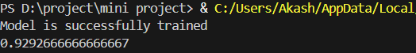

3.8.1 MODEL ACCURACY SCORE

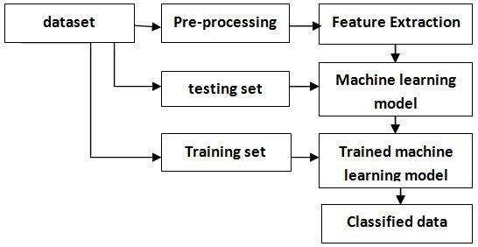

3.8.2 MODEL WOKFLOW REPRESENTATION

**CHAPTER 4**

**RESULTS AND DISCUSSION**

**4.1 COMPARING THE EXISTING MODEL AND OUR MODEL**

Traditional sentiment analysis models often rely on lexicon-based or simple machine learning approaches, such as keyword matching and basic classifiers like Logistic Regression or Naïve Bayes. These models struggle with understanding context, sarcasm, negations, and domain-specific language, leading to misclassification of sentiments. Additionally, they lack advanced preprocessing and feature extraction, making them ineffective for handling large-scale, real-world data. Furthermore, earlier models are prone to overfitting and poor generalization, meaning they perform well only on specific datasets but fail when exposed to diverse, unseen reviews.

In contrast, our Sentiment Analysis of Product Reviews system utilizes a Random Forest Classifier (RFC), an ensemble learning method that significantly enhances prediction accuracy and robustness. Unlike traditional models that depend on a fixed lexicon, our system learns sentiment patterns from data, allowing it to capture contextual meaning and adapt to different writing styles. By employing CountVectorizer for feature extraction, our model effectively transforms text into numerical vectors, making it more scalable and efficient for classification. Moreover, ensemble learning in RFC reduces overfitting, ensuring better generalization on unseen reviews compared to single-model approaches. Additionally, our system is deployed in an interactive Streamlit-based web application, providing users with a real-time sentiment prediction tool, unlike older models that require complex manual inputs.

Overall, our ML-driven approach outperforms traditional sentiment analysis models by providing better accuracy, handling complex text structures, reducing overfitting, and offering a user-friendly interface, making it a more efficient and scalable solution for sentiment classification.

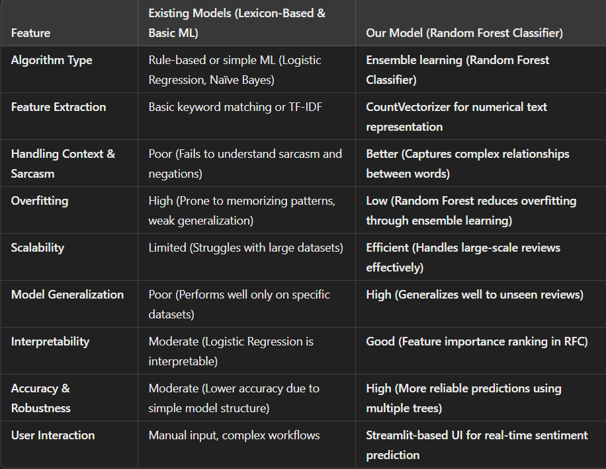

4.1.1 EXISTING MODEL VS OUR MODEL

4.2 **STREAMLIT OVER HTML, CSS AND GUI FRAMEWORKS**

When developing a sentiment analysis web application, choosing the right framework is crucial. Streamlit and HTML & CSS serve different purposes—Streamlit is a Python-based framework designed for data-driven applications, while HTML & CSS are fundamental web technologies used for building custom frontend designs. Since our Sentiment Analysis of Product Reviews project is ML-focused, Streamlit was the best choice due to its fast integration with Python, ease of deployment, and interactive UI components. Unlike HTML & CSS, which require separate backend development, Streamlit allows us to directly load our trained Random Forest model and display predictions instantly. This made our ML web app development faster, more efficient, and focused on functionality rather than frontend complexities.

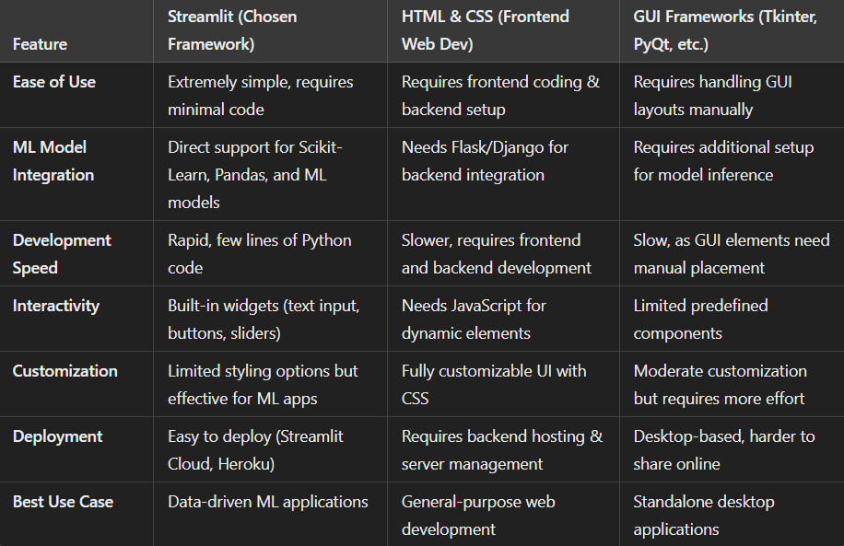

**4.2.1 STREAMLIT VS OTHER FRAMEWORK**

**CHAPTER 5**

**CONCLUSION AND FUTURE WORK**

**5.1 CONCLUSION**

The Sentiment Analysis of Product Reviews project successfully demonstrates how Machine Learning (ML) and Natural Language Processing (NLP) can be leveraged to extract meaningful insights from customer feedback. By utilizing a Random Forest Classifier (RFC) and CountVectorizer for feature extraction, the system efficiently classifies product reviews into positive, negative, or neutral sentiments. Compared to traditional lexicon-based approaches, our ML-driven model offers higher accuracy, better generalization, and improved robustness, ensuring reliable sentiment predictions.

Furthermore, the integration of Streamlit enables a user-friendly and interactive web application, allowing real-time sentiment analysis with minimal effort. The project workflow—from data collection and preprocessing to model training, evaluation, and deployment—illustrates a structured and scalable approach to sentiment classification. With further enhancements, such as hyperparameter tuning, deep learning models, or improved feature engineering, the system could be expanded for broader real-world applications, including brand monitoring, customer feedback analysis, and business intelligence. Overall, this project serves as an effective demonstration of AI-powered sentiment analysis, highlighting the impact of data-driven decision-making in modern businesses.

**5.2 FUTURE WORK**

While our Sentiment Analysis of Product Reviews project effectively classifies sentiments using a Random Forest Classifier (RFC) and CountVectorizer, several improvements can be made to enhance its performance and scalability. One potential improvement is the integration of deep learning models such as Recurrent Neural Networks (RNNs), Long Short-Term Memory (LSTM), or Transformer-based models like BERT, which can better capture the contextual meaning of words and improve sentiment classification accuracy. Additionally, replacing CountVectorizer with TF-IDF or word embeddings (Word2Vec, GloVe, or FastText) could help capture semantic relationships between words, leading to more meaningful feature extraction.

Another future enhancement could be expanding the dataset by incorporating real-time review scraping from e-commerce platforms or social media, enabling the model to stay up-to-date with evolving customer sentiments. Multilingual sentiment analysis can also be introduced, allowing the system to classify reviews in multiple languages. Further, hyperparameter tuning and model optimization can improve the efficiency and performance of the RFC model, ensuring better generalization on unseen data.

On the deployment side, integrating Streamlit with cloud services like AWS, Google Cloud, or Azure would enhance the system’s scalability, allowing for real-time sentiment predictions on large datasets. Additionally, adding data visualization dashboards could provide businesses with graphical insights into sentiment trends over time. Lastly, implementing bias detection and fairness checks in the model would help reduce potential biasesin sentiment classification, ensuring a more transparent and ethical AI system.

**APPENDIX A**

**A.1 SOURCE CODE**

**MODULE.PY:**

import pandas

import numpy

import sklearn

from sklearn.model_selection import train_test_split

from sklearn.feature_extraction.text import CountVectorizer

from sklearn.ensemble import RandomForestClassifier

import matplotlib.pyplot as plt

df=pandas.read_csv(r'D:\project\mini project\archive\Dataset-SA.csv')

df.head()

sentiment_count=df['Sentiment'].value_counts()

plt.plot(sentiment_count.index,sentiment_count.values)

plt.xlabel("Sentiment")

plt.ylabel("Count")

plt.title("EDA")

from wordcloud import WordCloud

text=''.join(df['Summary'].dropna())

wc=WordCloud(width=640,height=480,background_color='black').generate(text)

plt.figure(figsize=(10,5))

plt.imshow(wc)

df=df.sample(n=50000)

x=df['Summary'].fillna("")

y=df['Sentiment'].fillna("")

x_train,x_test,y_train,y_test=train_test_split(x,y,train_size=0.7,random_state=42)

vec=CountVectorizer()

X_train=vec.fit_transform(x_train)

X_test=vec.transform(x_test)

from sklearn.preprocessing import LabelEncoder

enc=LabelEncoder()

Y_train=enc.fit_transform(y_train)

Y_test=enc.transform(y_test)

rfc=RandomForestClassifier()

rfc.fit(X_train,y_train)

print("Model is successfully trained")

print(rfc.score(X_test,y_test))

def predictor(text):

    prediction=rfc.predict(vec.transform([text]))

    return prediction

**HOSTCODE.PY:**

import streamlit as st

import time

st.title("***SENTIMENTAL ANALYSIS ON PRODUCT REVIEWS***")

st.logo(r"D:\project\mini project\archive\DALL·E 2025-03-18 19.00.24 - A modern and futuristic logo for a team named 'HAK'. The design should feature a neon color scheme with vibrant blue, purple, and pink neon glow effec.webp")

st.divider()

st.header("***About Me***")

st.write("""Sentiment analysis of product reviews is crucial for understanding customer opinions and improving business strategies. This project utilizes a Random Forest classifier to predict the sentiment of textual reviews. TF-IDF, CountVectorizer, and word embeddings are employed for feature extraction to capture meaningful text representations. The model is trained on labeled review data and evaluated using accuracy, precision, recall, and F1-score. By leveraging ensemble learning, the Random Forest classifier enhances prediction robustness, making it a reliable approach for sentiment classification.

    """)

st.divider()

st.subheader("***Insights from the product***")

st.caption("**Hey there, Initially loading of model would take atleast a minute, meanwhile go through the video below and get to know about our product**")

st.video(r'D:\project\mini project\archive\Akash_project_1.mp4')

st.divider()

with st.spinner("Getting the model ready..",show_time=True):

    import mainmod as md

    st.success("The model is now trained")

st.divider()

st.caption("***feed some text to analyze the sentiments***")

text=st.text_input("_shoot the text_","this is a default text")

predval=md.predictor(text)

st.write(f"***Sentiment***: :blue[{predval}]")

with st.sidebar:

    st.sidebar.write("***Jaane se pehle***")

    g2g=st.sidebar.checkbox("*About my Guru*")

    if g2g:

        st.sidebar.caption("***developed by Akash***")

        st.sidebar.caption("***Contact us - hak181318@gmail.com***")

st.divider()

**A.2 SCREENSHOTS**

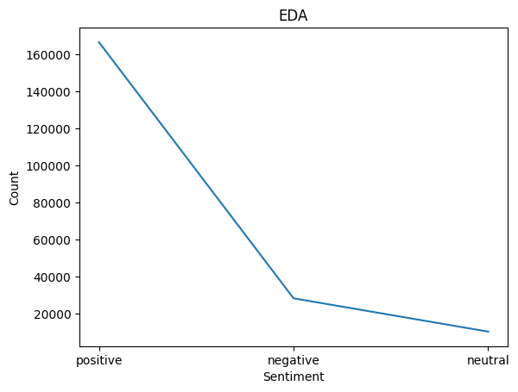

A.2.1 EDA RESULT

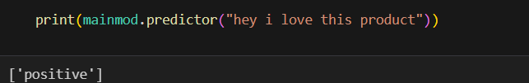

A.2.2 BASIC PREDICTION

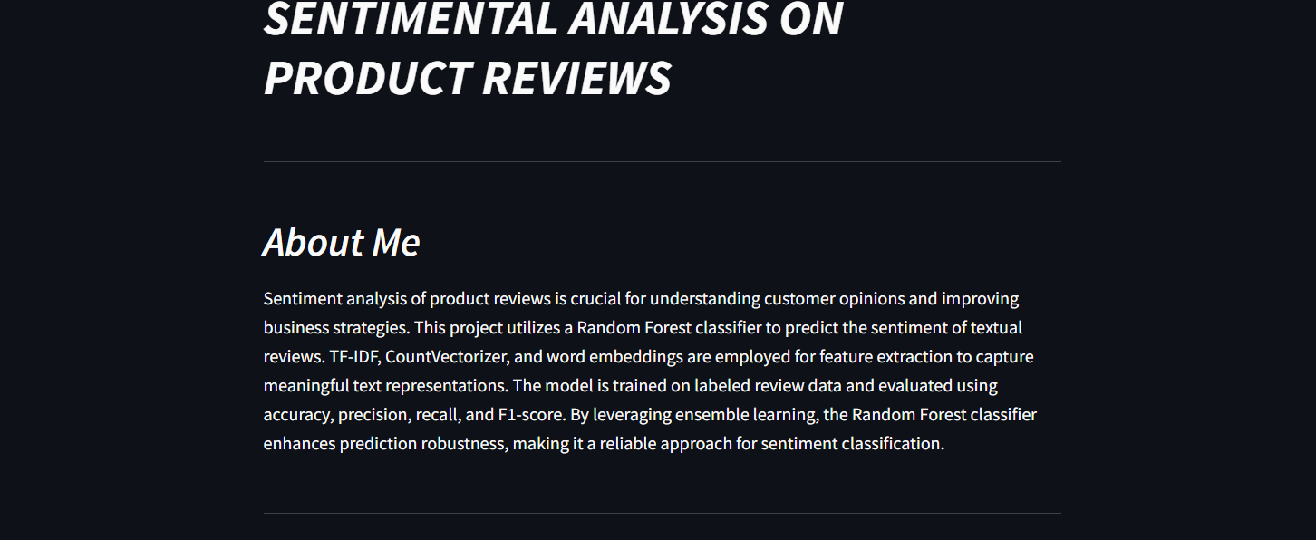

A.2.3 GENERAL USER INTERFACE 1



A.2.4 GENERAL USER INTERFACE 2

**REFERENCES**

1. Vajjala, S., Majumder, B., Gupta, A., & Surana, H. (2020). *Practical Natural Language Processing: A Comprehensive Guide to Building Real-World NLP Systems*. O'Reilly Media.
2. Theobald, O. (2017). *Machine Learning for Absolute Beginners*. Scatterplot Press.
3. Géron, A. (2019). *Hands-On Machine Learning with Scikit-Learn, Keras, and TensorFlow*. O'Reilly Media.
4. McKinney, W. (2017). *Python for Data Analysis: Data Wrangling with Pandas, NumPy, and Jupyter* (2nd ed.). O'Reilly Media.
5. Streamlit. (2024). *Streamlit Documentation: Create Interactive Web Apps for Machine Learning and Data Science*. Streamlit Inc.
6. Pedregosa, F., Varoquaux, G., Gramfort, A., Michel, V., Thirion, B., Grisel, O., Blondel, M., Prettenhofer, P., Weiss, R., Dubourg, V., Vanderplas, J., Passos, A., Cournapeau, D., Brucher, M., Perrot, M., & Duchesnay, É. (2011). *Scikit-learn: Machine Learning in Python*. *Journal of Machine Learning Research*, 12, 2825–2830.
7. Bird, S., Klein, E., & Loper, E. (2009). *Natural Language Processing with Python: Analyzing Text with the Natural Language Toolkit*. O'Reilly Media.
8. Patel, D. (n.d.). *Codebasics: Machine Learning and NLP Tutorials*. Codebasics. Retrieved from <https://codebasics.io>.